CLASS TEST-4

1.

AREA AND PERIMETER A RECTANGLE AND TRIANGLE

code:

abstract class Shape {

public abstract double calculateArea();

public abstract double calculatePerimeter();

}

class Rectangle extends Shape {

private double length;

private double width;

public Rectangle(double length, double width) {

this.length = length;

this.width = width;

}

public double calculateArea() {

return length \* width;

}

public double calculatePerimeter() {

return 2 \* (length + width);

}

}

class Triangle extends Shape {

private double side1;

private double side2;

private double side3;

public Triangle(double side1, double side2, double side3) {

this.side1 = side1;

this.side2 = side2;

this.side3 = side3;

}

public double calculateArea() {

double s = (side1 + side2 + side3) / 2;

return Math.sqrt(s \* (s - side1) \* (s - side2) \* (s - side3));

}

public double calculatePerimeter() {

return side1 + side2 + side3;

}

}

public class Main {

public static void main(String[] args) {

Rectangle rectangle = new Rectangle(10, 20);

System.out.println("Rectangle area: " + rectangle.calculateArea());

System.out.println("Rectangle perimeter: " + rectangle.calculatePerimeter());

Triangle triangle = new Triangle(5, 12, 13);

System.out.println("Triangle area: " + triangle.calculateArea());

System.out.println("Triangle perimeter: " + triangle.calculatePerimeter());

}

}

Output:

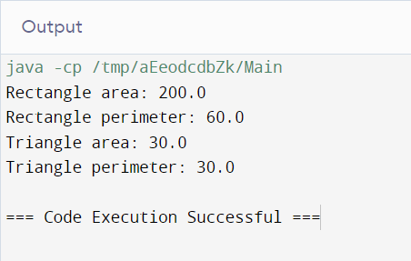

2.ANIMAL MOVES

Code:

abstract class Animal {

public abstract void move();

}

class Bird extends Animal {

public void move() {

System.out.println("Bird flies.");

}

}

class Fish extends Animal {

public void move() {

System.out.println("Fish swims.");

}

}

public class Main {

public static void main(String[] args) {

Bird sparrow = new Bird();

sparrow.move();

Fish salmon = new Fish();

salmon.move();

}

}

Output:

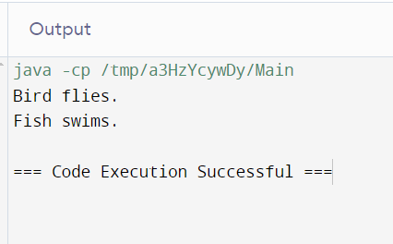

3.GREETINGS

Code:

abstract class person {

public abstract void greet();

}

class student extends person {

public void greet() {

System.out.println("student : good morning teacher");

}

}

class teacher extends person {

public void greet() {

System.out.println("teacher : good morning student");

}

}

public class Main {

public static void main(String[] args) {

student s1 = new student();

s1.greet();

teacher t1 = new teacher();

t1.greet();

}

}

Output:

